Attachment：
The sheet of Seng Hin Rubber (M) Sdn. Bhd. TSR 20 futures product logo
Registered Enterprise | Factory Code/Manufacturer (Factory) | Old Version of Product Logo | New Version of Product Logo
Seng Hin Rubber (M) Sdn. Bhd. | BY | 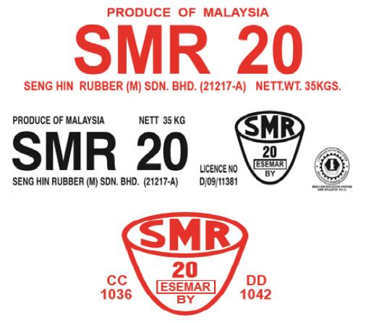 | 