Attachment：
The sheet of PT. Hok Tong TSR 20 futures product logo
Registered Enterprise | Factory Code/Manufacturer (Factory) | Old Version of Product Logo | New Version of Product Logo
PT. Hok Tong | SGO | 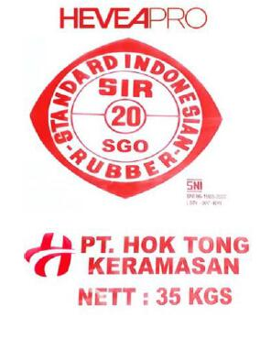 | 