Attachment：
The sheet of Sri Trang Agro-Industry Public Co., Ltd. TSR 20 futures product logo
Registered Enterprise | Factory Code/Manufacturer (Factory) | Old Version of Product Logo | New Version of Product Logo
Sri Trang Agro -industry Public Co., Ltd. | BD1 | 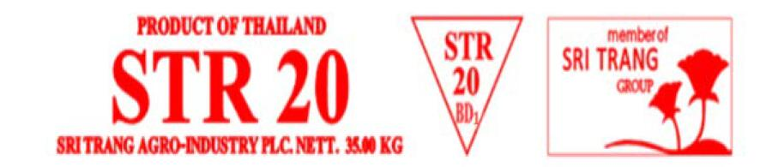 | 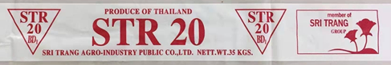
Sri Trang Agro -industry Public Co., Ltd. | BD2 | 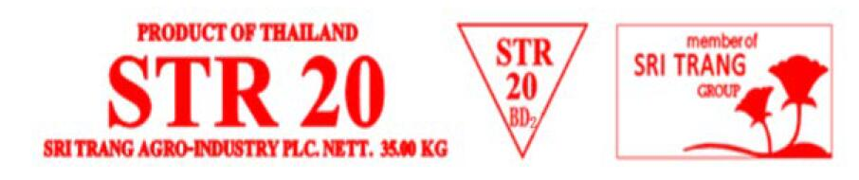 | 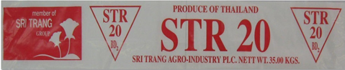
Sri Trang Agro -industry Public Co., Ltd. | BD5 | 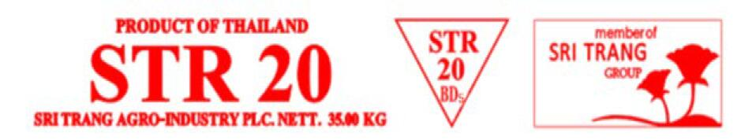 | 