Attachment：
The sheet of Thaitech Rubber Corporation Ltd. TSR 20 futures product logo
Registered Enterprise | Factory Code/Manufacturer (Factory) | Old Version of Product Logo | New Version of Product Logo
Thaitech Rubber Corporation Ltd. | AG1 | 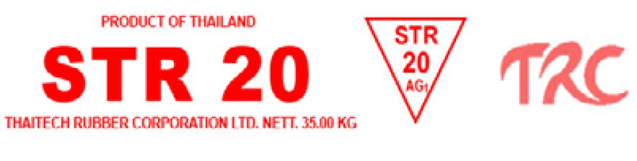 | 