Attachment：
The Form of Southland Resources Co., Ltd. TSR 20 futures product logo
Registered Enterprise | Factory Code/Manufacturer (Factory) | Old Version of Product Logo | New Version of Product Logo
Southland Resources Co., Ltd. | FB | 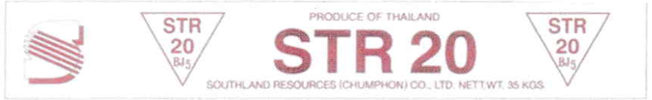 | 