Attachment：
The Form of PT Sri Trang Lingga Indonesia TSR 20 futures product belt designs

Registered Enterprise | Factory Code/Manufacturer (Factory) | Original Version of Product belt design | New Version of Product  belt design
PT Sri Trang Lingga Indonesia | SFZ | 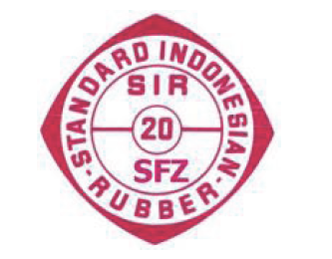 | 