Attachment：
The Form of PT Sri Trang Lingga Indonesia TSR 20 Futures Product Belt Design

Registered Enterprise | Factory Code/Manufacturer (Factory) | Original Version of Product Belt Design | New Version of Product  Belt Design
PT Sri Trang Lingga Indonesia | SFZ | 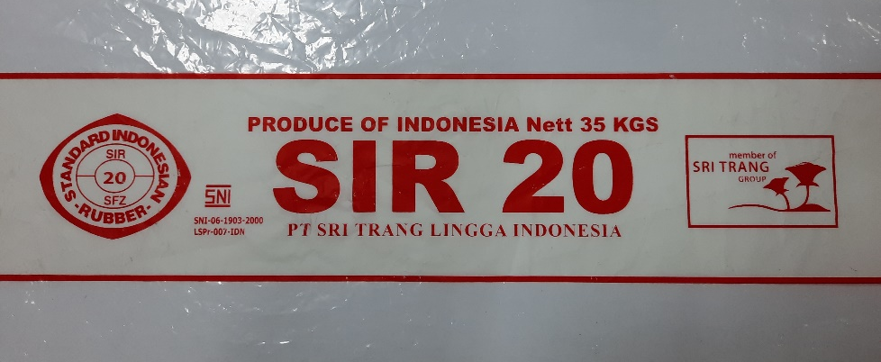 | 