Attachment：

The Form of Teck Bee Hang Co., Ltd. TSR 20 Futures Product Belt Design
Registered Enterprise | Factory Code/  Manufacturer (Factory) | Product belt design
Teck Bee Hang Co., Ltd. | H2 | 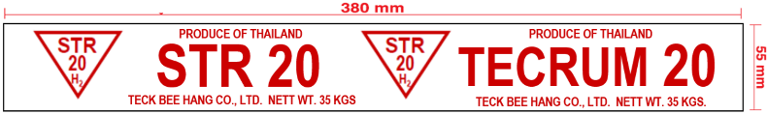 | Old design
 |  | 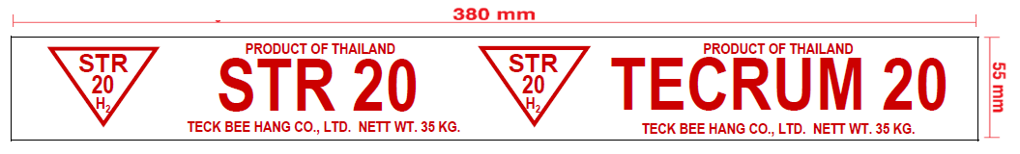 | New design
 | H6 | 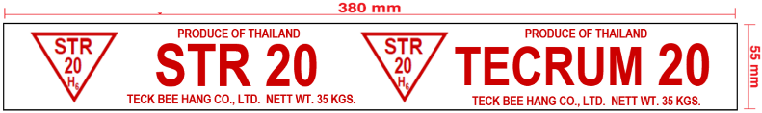 | Old design
 |  | 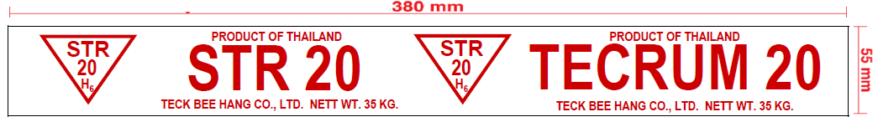 | New design
 | H8 | 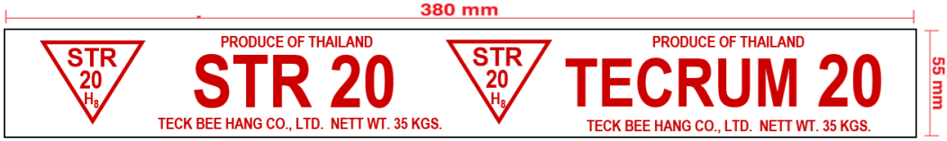 | Old design
 |  | 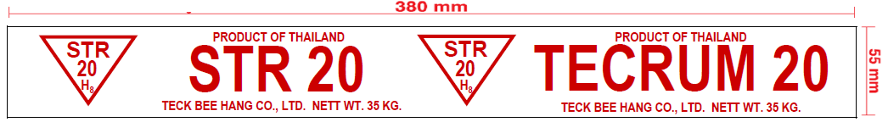 | New design

