Attachment：
The Form of Yunnan Natural Rubber Industry Group Co., Ltd.
TSR 20 Futures Product Marking Design
Product Marking Design
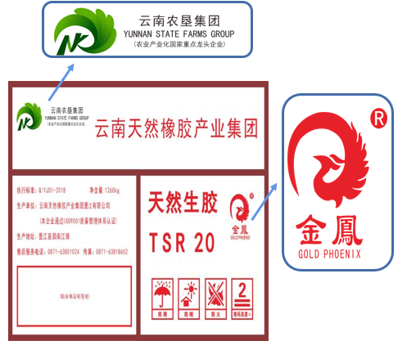  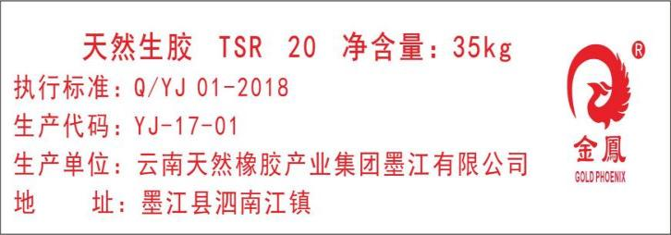 | Old design
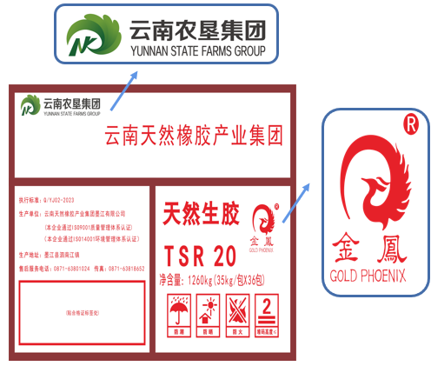  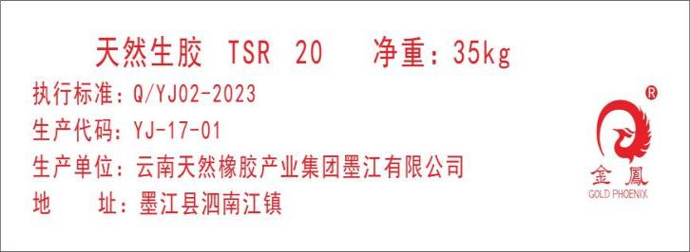 | New design
Factory Code：YJ-17-01

